**WEEK-4**

**Spring REST using Spring Boot 3**

**1. Create a Spring Web Project using Maven**

**pom.xml**

<?xml version="1.0" encoding="UTF-8"?>  
<project xmlns="http://maven.apache.org/POM/4.0.0" xmlns:xsi="http://www.w3.org/2001/XMLSchema-instance"  
 xsi:schemaLocation="http://maven.apache.org/POM/4.0.0 https://maven.apache.org/xsd/maven-4.0.0.xsd">  
 <modelVersion>4.0.0</modelVersion>  
 <parent>  
 <groupId>org.springframework.boot</groupId>  
 <artifactId>spring-boot-starter-parent</artifactId>  
 <version>3.5.3</version>  
 <relativePath/>   
 </parent>  
 <groupId>com.cognizant</groupId>  
 <artifactId>spring-learn</artifactId>  
 <version>0.0.1-SNAPSHOT</version>  
 <name>spring-learn</name>  
 <description>Demo project for Spring Boot</description>  
 <url/>  
 <licenses>  
 <license/>  
 </licenses>  
 <developers>  
 <developer/>  
 </developers>  
 <scm>  
 <connection/>  
 <developerConnection/>  
 <tag/>  
 <url/>  
 </scm>  
 <properties>  
 <java.version>17</java.version>  
 </properties>  
 <dependencies>  
 <dependency>  
 <groupId>org.springframework.boot</groupId>  
 <artifactId>spring-boot-starter-web</artifactId>  
 </dependency>  
  
 <dependency>  
 <groupId>org.springframework.boot</groupId>  
 <artifactId>spring-boot-devtools</artifactId>  
 <scope>runtime</scope>  
 <optional>true</optional>  
 </dependency>  
 <dependency>  
 <groupId>org.springframework.boot</groupId>  
 <artifactId>spring-boot-starter-test</artifactId>  
 <scope>test</scope>  
 </dependency>  
 </dependencies>  
  
 <build>  
 <plugins>  
 <plugin>  
 <groupId>org.springframework.boot</groupId>  
 <artifactId>spring-boot-maven-plugin</artifactId>  
 </plugin>  
 </plugins>  
 </build>  
  
</project>

**SpringLearnApplication.java**

package com.cognizant.spring_learn;  
  
import org.springframework.boot.SpringApplication;  
import org.springframework.boot.autoconfigure.SpringBootApplication;  
  
@SpringBootApplication  
public class SpringLearnApplication {  
  
 public static void main(String[] args) {  
 SpringApplication.run(SpringLearnApplication.class, args);  
 System.out.println("Spring Boot Application Started");  
 }  
}

**Output:**

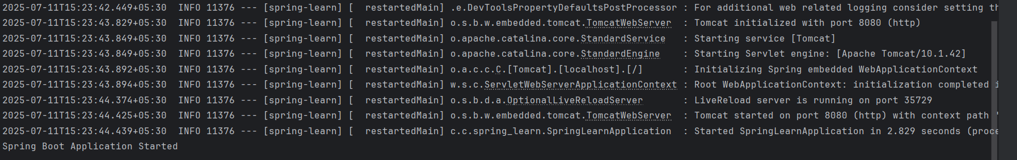

**2. Spring Core - Load Country from Spring Configuration XML**

package com.cognizant.spring_learn;  
  
import org.slf4j.Logger;  
import org.slf4j.LoggerFactory;  
import org.springframework.context.ApplicationContext;  
import org.springframework.context.support.ClassPathXmlApplicationContext;  
import org.springframework.boot.autoconfigure.SpringBootApplication;  
import org.springframework.boot.SpringApplication;  
  
@SpringBootApplication  
public class SpringLearnApplication {  
  
 private static final Logger LOGGER= LoggerFactory.getLogger(SpringLearnApplication.class);  
  
 public static void main(String[] args) {  
 SpringApplication.run(SpringLearnApplication.class, args);  
 displayCountry();  
 }  
  
 public static void displayCountry() {  
 ApplicationContext context = new ClassPathXmlApplicationContext("country.xml");  
  
 Country country = context.getBean("country", Country.class);  
 LOGGER.debug("Country : {}", country.toString());  
 }  
}

**Country.java**

package com.cognizant.spring_learn;  
  
import org.slf4j.Logger;  
import org.slf4j.LoggerFactory;  
  
public class Country {  
 private static final Logger LOGGER= LoggerFactory.getLogger(Country.class);  
  
 private String code;  
 private String name;  
  
 public Country() {  
 LOGGER.debug("Inside Country Constructor.");  
 }  
  
 public String getCode() {  
 LOGGER.debug("Inside getCode()");  
 return code;  
 }  
  
 public void setCode(String code) {  
 LOGGER.debug("Inside setCode()");  
 this.code = code;  
 }  
  
 public String getName() {  
 LOGGER.debug("Inside getName()");  
 return name;  
 }  
  
 public void setName(String name) {  
 LOGGER.debug("Inside setName()");  
 this.name = name;  
 }  
  
 @Override  
 public String toString() {  
 return "Country [code=" + code + ", name=" + name + "]";  
 }  
}

**country.xml**

<?xml version="1.0" encoding="UTF-8"?>  
<beans xmlns="http://www.springframework.org/schema/beans"  
 xmlns:xsi="http://www.w3.org/2001/XMLSchema-instance"  
 xsi:schemaLocation="http://www.springframework.org/schema/beans  
 http://www.springframework.org/schema/beans/spring-beans.xsd">  
  
 <bean id="country" class="com.cognizant.spring_learn.Country">  
 <property name="code" value="IN" />  
 <property name="name" value="India" />  
 </bean>  
  
</beans>

**Output:**

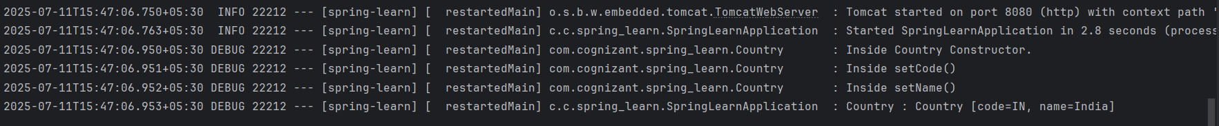

**3. Hello World RESTful Web Service   
HelloController.java**

package com.cognizant.spring_learn.controller;  
  
import org.slf4j.Logger;  
import org.slf4j.LoggerFactory;  
import org.springframework.web.bind.annotation.GetMapping;  
import org.springframework.web.bind.annotation.RestController;  
  
@RestController  
public class HelloController {  
  
 private static final Logger LOGGER= LoggerFactory.getLogger(HelloController.class);  
  
 @GetMapping("/hello")  
 public String sayHello() {  
 LOGGER.info("START sayHello()");  
 String message = "Hello World!!";  
 LOGGER.info("END sayHello()");  
 return message;  
 }  
}

**application.properties**

spring.application.name=spring-learn  
server.port=8083  
logging.level.com.cognizant.spring_learn=DEBUG

**Output:**

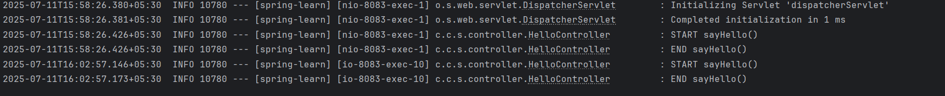

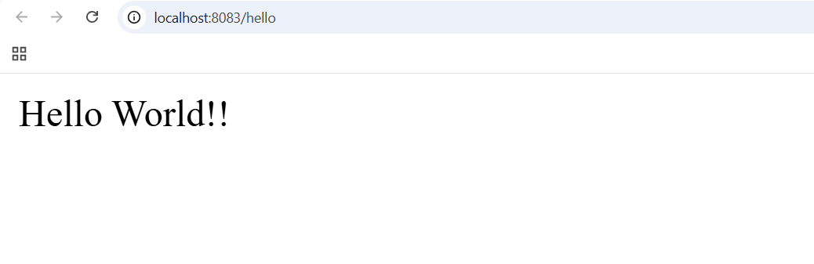

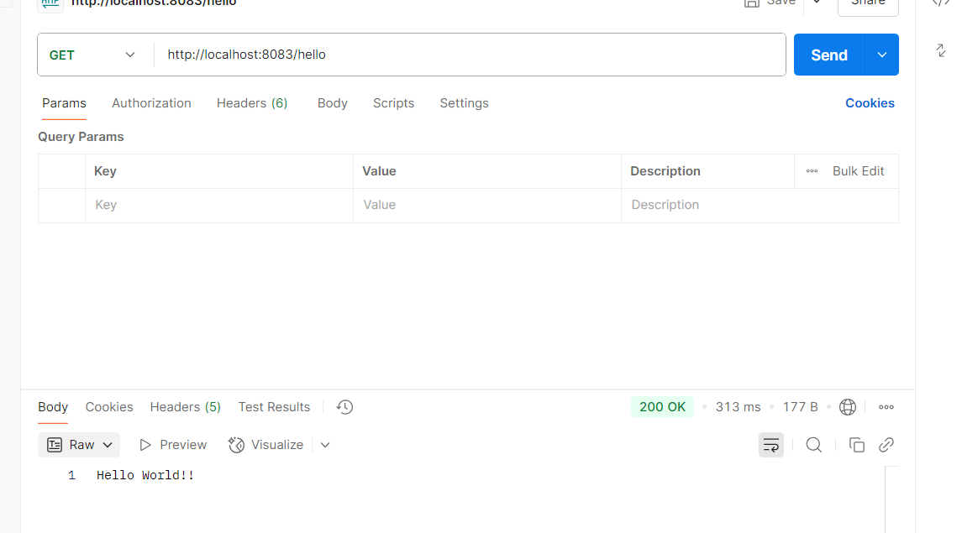

**4. REST - Country Web Service**

**country.xml**

<?xml version="1.0" encoding="UTF-8"?>  
<beans xmlns="http://www.springframework.org/schema/beans"  
 xmlns:xsi="http://www.w3.org/2001/XMLSchema-instance"  
 xsi:schemaLocation="http://www.springframework.org/schema/beans  
 https://www.springframework.org/schema/beans/spring-beans.xsd">  
  
 <bean id="country" class="com.cognizant.spring_learn.model.Country">  
 <property name="code" value="IN"/>  
 <property name="name" value="India"/>  
 </bean>  
</beans>

**Country.java**

package com.cognizant.spring_learn.model;  
  
import org.slf4j.Logger;  
import org.slf4j.LoggerFactory;  
  
public class Country {  
  
 private static final Logger LOGGER = LoggerFactory.getLogger(Country.class);  
  
 private String code;  
 private String name;  
  
 public Country() {  
 LOGGER.debug("Inside Country Constructor.");  
 }  
  
 public String getCode() {  
 LOGGER.debug("Inside getCode()");  
 return code;  
 }  
  
 public void setCode(String code) {  
 LOGGER.debug("Inside setCode()");  
 this.code = code;  
 }  
  
 public String getName() {  
 LOGGER.debug("Inside getName()");  
 return name;  
 }  
  
 public void setName(String name) {  
 LOGGER.debug("Inside setName()");  
 this.name = name;  
 }  
  
 @Override  
 public String toString() {  
 return "Country [code=" + code + ", name=" + name + "]";  
 }  
}

**CountryController.java**

package com.cognizant.spring_learn.controller;  
  
import com.cognizant.spring_learn.model.Country;  
import org.slf4j.Logger;  
import org.slf4j.LoggerFactory;  
import org.springframework.context.ApplicationContext;  
import org.springframework.context.support.ClassPathXmlApplicationContext;  
import org.springframework.web.bind.annotation.RequestMapping;  
import org.springframework.web.bind.annotation.RestController;  
  
@RestController  
public class CountryController {  
  
 private static final Logger LOGGER = LoggerFactory.getLogger(CountryController.class);  
  
 @RequestMapping("/country")  
 public Country getCountryIndia() {  
 LOGGER.info("START getCountryIndia()");  
 ApplicationContext context = new ClassPathXmlApplicationContext("country.xml");  
 Country country = (Country) context.getBean("country", Country.class);  
 LOGGER.info("END getCountryIndia()");  
 return country;   
 }  
}

**Output:**

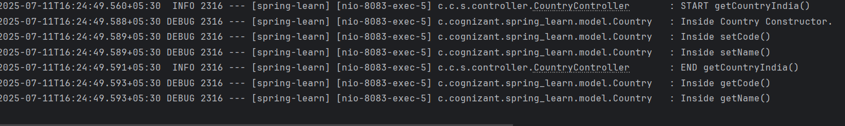

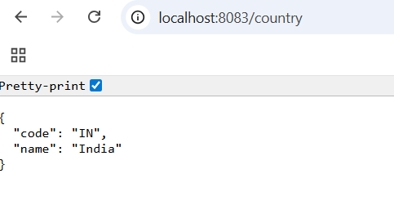

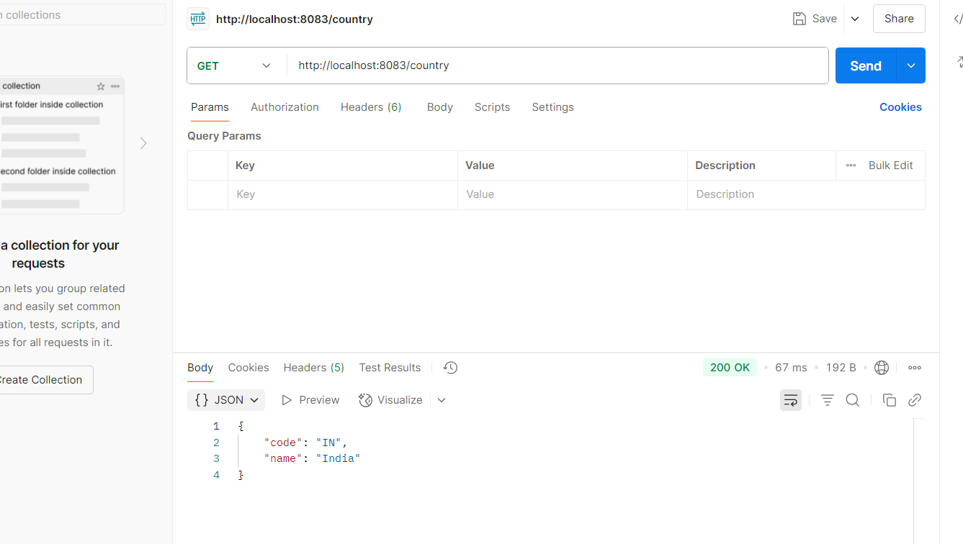

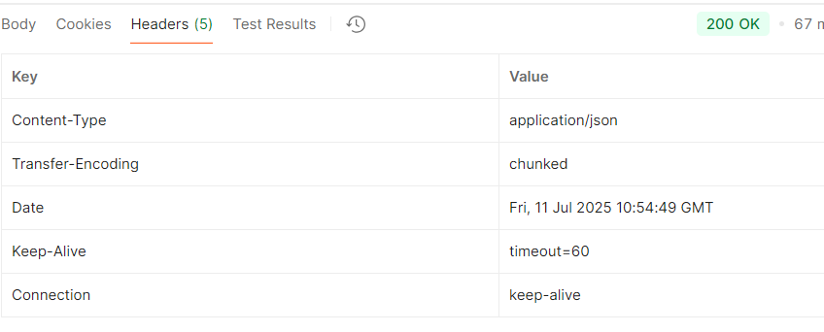

**5. REST - Get country based on country code**

**country.xml**

<?xml version="1.0" encoding="UTF-8"?>  
<beans xmlns="http://www.springframework.org/schema/beans"  
 xmlns:xsi="http://www.w3.org/2001/XMLSchema-instance"  
 xsi:schemaLocation="http://www.springframework.org/schema/beans  
 https://www.springframework.org/schema/beans/spring-beans.xsd">  
  
 <bean id="country" class="com.cognizant.spring_learn.model.Country">  
 <property name="code" value="IN"/>  
 <property name="name" value="India"/>  
 </bean>  
  
 <bean id="countryList" class="java.util.ArrayList">  
 <constructor-arg>  
 <list>  
 <bean class="com.cognizant.spring_learn.model.Country">  
 <property name="code" value="IN"/>  
 <property name="name" value="India"/>  
 </bean>  
 <bean class="com.cognizant.spring_learn.model.Country">  
 <property name="code" value="US"/>  
 <property name="name" value="United States"/>  
 </bean>  
 <bean class="com.cognizant.spring_learn.model.Country">  
 <property name="code" value="DE"/>  
 <property name="name" value="Germany"/>  
 </bean>  
 <bean class="com.cognizant.spring_learn.model.Country">  
 <property name="code" value="JP"/>  
 <property name="name" value="Japan"/>  
 </bean>  
 </list>  
 </constructor-arg>  
 </bean>  
</beans>

**CountryService.java**

package com.cognizant.spring_learn.service;  
  
import com.cognizant.spring_learn.model.Country;  
import org.springframework.context.ApplicationContext;  
import org.springframework.context.support.ClassPathXmlApplicationContext;  
import org.springframework.stereotype.Service;  
  
import java.util.List;  
  
@Service  
public class CountryService {  
  
 public Country getCountry(String code) {  
 ApplicationContext context = new ClassPathXmlApplicationContext("country.xml");  
 List<Country> countryList = context.getBean("countryList", List.class);  
  
 return countryList.stream()  
 .filter(country -> country.getCode().equalsIgnoreCase(code))  
 .findFirst()  
 .orElse(null);   
 }  
}

**CountryController.java**

package com.cognizant.spring_learn.controller;  
  
import com.cognizant.spring_learn.model.Country;  
import com.cognizant.spring_learn.service.CountryService;  
import org.slf4j.Logger;  
import org.slf4j.LoggerFactory;  
import org.springframework.beans.factory.annotation.Autowired;  
import org.springframework.web.bind.annotation.*;  
  
@RestController  
public class CountryController {  
  
 private static final Logger LOGGER = LoggerFactory.getLogger(CountryController.class);  
  
 @Autowired  
 private CountryService countryService;  
  
 @GetMapping("/countries/{code}")  
 public Country getCountry(@PathVariable String code) {  
 LOGGER.info("START getCountry() with code: {}", code);  
 Country country = countryService.getCountry(code);  
 LOGGER.info("END getCountry()");  
 return country;  
 }  
}

**Country.java**

package com.cognizant.spring_learn.model;  
  
import org.slf4j.Logger;  
import org.slf4j.LoggerFactory;  
  
public class Country {  
  
 private static final Logger LOGGER = LoggerFactory.getLogger(Country.class);  
  
 private String code;  
 private String name;  
  
 public Country() {  
 LOGGER.debug("Inside Country Constructor.");  
 }  
  
 public String getCode() {  
 LOGGER.debug("Inside getCode()");  
 return code;  
 }  
  
 public void setCode(String code) {  
 LOGGER.debug("Inside setCode()");  
 this.code = code;  
 }  
  
 public String getName() {  
 LOGGER.debug("Inside getName()");  
 return name;  
 }  
  
 public void setName(String name) {  
 LOGGER.debug("Inside setName()");  
 this.name = name;  
 }  
  
 @Override  
 public String toString() {  
 return "Country [code=" + code + ", name=" + name + "]";  
 }  
}

**application.properties**

spring.application.name=spring-learn  
server.port=8083  
logging.level.com.cognizant.spring_learn=DEBUG

**Output:**

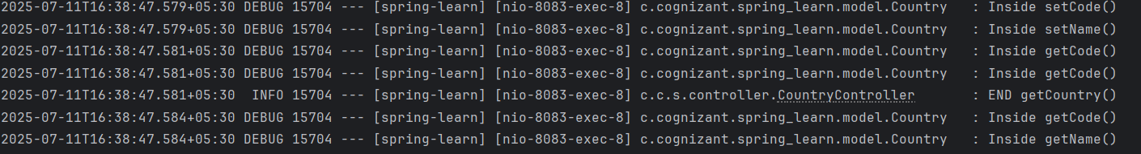

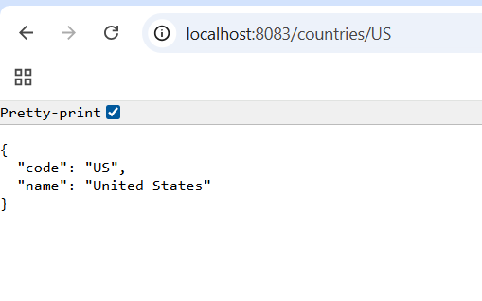

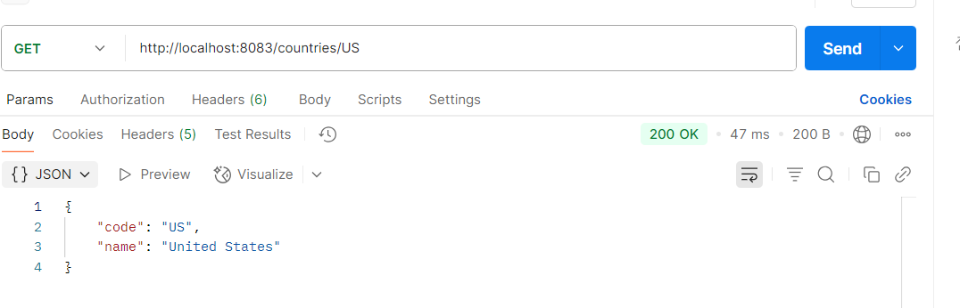

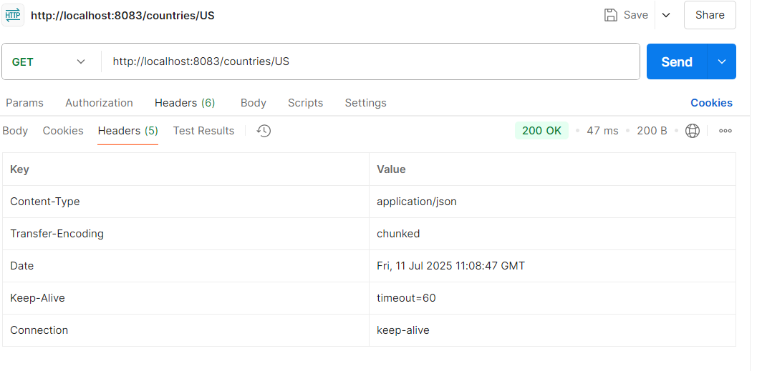

**6. Create authentication service that returns JWT**

**SpringLearnApplication.java**

package com.cognizant.spring_learn;  
  
import org.slf4j.Logger;  
import org.slf4j.LoggerFactory;  
import org.springframework.context.ApplicationContext;  
import org.springframework.context.support.ClassPathXmlApplicationContext;  
import org.springframework.boot.autoconfigure.SpringBootApplication;  
import org.springframework.boot.SpringApplication;  
import com.cognizant.spring_learn.model.Country;  
  
  
@SpringBootApplication  
public class SpringLearnApplication {  
  
 private static final Logger LOGGER = LoggerFactory.getLogger(SpringLearnApplication.class);  
  
 public static void main(String[] args) {  
 SpringApplication.run(SpringLearnApplication.class, args);  
 displayCountry();  
 }  
  
 public static void displayCountry() {  
 ApplicationContext context = new ClassPathXmlApplicationContext("country.xml");  
  
 Country country = context.getBean("country", Country.class);  
 LOGGER.debug("Country : {}", country.toString());  
 }  
}

**application.properties**

spring.application.name=spring-learn  
server.port=8090  
logging.level.com.cognizant.spring_learn=DEBUG

**pom.xml**

<?xml version="1.0" encoding="UTF-8"?>  
<project xmlns="http://maven.apache.org/POM/4.0.0"  
 xmlns:xsi="http://www.w3.org/2001/XMLSchema-instance"  
 xsi:schemaLocation="http://maven.apache.org/POM/4.0.0 https://maven.apache.org/xsd/maven-4.0.0.xsd">  
  
 <modelVersion>4.0.0</modelVersion>  
  
 <parent>  
 <groupId>org.springframework.boot</groupId>  
 <artifactId>spring-boot-starter-parent</artifactId>  
 <version>3.5.3</version>  
 <relativePath/>  
 </parent>  
  
 <groupId>com.cognizant</groupId>  
 <artifactId>spring-learn</artifactId>  
 <version>0.0.1-SNAPSHOT</version>  
 <name>spring-learn</name>  
 <description>Demo project for Spring Boot</description>  
  
 <properties>  
 <java.version>17</java.version>  
 </properties>  
  
 <dependencies>  
 <dependency>  
 <groupId>org.springframework.boot</groupId>  
 <artifactId>spring-boot-starter-web</artifactId>  
 </dependency>  
 <dependency>  
 <groupId>org.springframework</groupId>  
 <artifactId>spring-context</artifactId>  
 </dependency>  
 <dependency>  
 <groupId>org.springframework.boot</groupId>  
 <artifactId>spring-boot-devtools</artifactId>  
 <scope>runtime</scope>  
 <optional>true</optional>  
 </dependency>  
 <dependency>  
 <groupId>org.springframework.boot</groupId>  
 <artifactId>spring-boot-starter-test</artifactId>  
 <scope>test</scope>  
 </dependency>  
 <dependency>  
 <groupId>org.springframework.boot</groupId>  
 <artifactId>spring-boot-starter-security</artifactId>  
 </dependency>  
 <dependency>  
 <groupId>org.springframework.security</groupId>  
 <artifactId>spring-security-config</artifactId>  
 </dependency>  
  
 <dependency>  
 <groupId>jakarta.servlet</groupId>  
 <artifactId>jakarta.servlet-api</artifactId>  
 <version>6.0.0</version>  
 <scope>provided</scope>  
 </dependency>  
 <dependency>  
 <groupId>io.jsonwebtoken</groupId>  
 <artifactId>jjwt-api</artifactId>  
 <version>0.11.5</version>  
 </dependency>  
 <dependency>  
 <groupId>io.jsonwebtoken</groupId>  
 <artifactId>jjwt-impl</artifactId>  
 <version>0.11.5</version>  
 <scope>runtime</scope>  
 </dependency>  
 <dependency>  
 <groupId>io.jsonwebtoken</groupId>  
 <artifactId>jjwt-jackson</artifactId>  
 <version>0.11.5</version>  
 <scope>runtime</scope>  
 </dependency>  
  
 </dependencies>  
  
 <build>  
 <plugins>  
 <plugin>  
 <groupId>org.springframework.boot</groupId>  
 <artifactId>spring-boot-maven-plugin</artifactId>  
 </plugin>  
 </plugins>  
 </build>  
  
</project>

**JwtUtil.java**

package com.cognizant.spring_learn.util;  
  
import io.jsonwebtoken.Jwts;  
import io.jsonwebtoken.SignatureAlgorithm;  
import io.jsonwebtoken.security.Keys;  
  
import java.security.Key;  
import java.util.Date;  
  
public class JwtUtil {  
 private static final Key key = Keys.secretKeyFor(SignatureAlgorithm.HS256);   
 public static String generateToken(String username) {  
 return Jwts.builder()  
 .setSubject(username)  
 .setIssuedAt(new Date(System.currentTimeMillis()))  
 .setExpiration(new Date(System.currentTimeMillis() + 1000 * 60 * 10)) // 10 minutes  
 .signWith(key)  
 .compact();  
 }  
}

**AuthController.java**

package com.cognizant.spring_learn.controller;  
  
import com.cognizant.spring_learn.util.JwtUtil;  
import org.springframework.http.ResponseEntity;  
import org.springframework.web.bind.annotation.*;  
  
import java.nio.charset.StandardCharsets;  
import java.util.Base64;  
import java.util.Map;  
  
@RestController  
public class AuthController {  
  
 @GetMapping("/authenticate")  
 public ResponseEntity<Map<String, String>> authenticate(@RequestHeader("Authorization") String authHeader) {  
 if (authHeader == null || !authHeader.startsWith("Basic ")) {  
 return ResponseEntity.status(401).body(Map.of("error", "Missing Authorization Header"));  
 }  
  
 String base64Credentials = authHeader.substring("Basic ".length());  
 byte[] credDecoded = Base64.getDecoder().decode(base64Credentials);  
 String credentials = new String(credDecoded, StandardCharsets.UTF_8);  
  
 String[] values = credentials.split(":", 2);  
 if (values.length != 2) {  
 return ResponseEntity.status(400).body(Map.of("error", "Invalid Authorization Format"));  
 }  
  
 String username = values[0];  
 String password = values[1];  
  
 if (username.equals("user") && password.equals("pwd")) {  
 String token = JwtUtil.generateToken(username);  
 return ResponseEntity.ok(Map.of("token", token));  
 } else {  
 return ResponseEntity.status(401).body(Map.of("error", "Invalid Credentials"));  
 }  
 }  
}

**SecurityConfig.java**

package com.cognizant.spring_learn.config;  
import org.springframework.context.annotation.Bean;  
import org.springframework.context.annotation.Configuration;  
import org.springframework.security.config.annotation.web.builders.HttpSecurity;  
import org.springframework.security.core.userdetails.User;  
import org.springframework.security.core.userdetails.UserDetails;  
import org.springframework.security.core.userdetails.UserDetailsService;  
import org.springframework.security.provisioning.InMemoryUserDetailsManager;  
import org.springframework.security.web.SecurityFilterChain;  
  
@Configuration  
public class SecurityConfig {  
  
 @Bean  
 public UserDetailsService userDetailsService() {  
 UserDetails user = User  
 .withUsername("user")  
 .password("{noop}pwd")   
 .roles("USER")  
 .build();  
 return new InMemoryUserDetailsManager(user);  
 }  
  
 @Bean  
 public SecurityFilterChain filterChain(HttpSecurity http) throws Exception {  
 http  
 .csrf(csrf -> csrf.disable())  
 .authorizeHttpRequests(auth -> auth  
 .requestMatchers("/authenticate").permitAll()  
 .anyRequest().authenticated()  
 )  
 .httpBasic(httpBasic -> {});   
  
 return http.build();  
 }  
}

**Output:**

